MATH 486 TERM PROJECT REPORT

The purpose of the term project is creating database of Spotify. First of all, we began to identify entities which are basics of Spotify by analyzing menu of Spotify. Analyzing process includes gathering entitites which are essential to it, determining certain attributes, their data types and restrictions We collected all the entities such as user,artists,songs etc .For each entity ,we specified certain attributes.like user name ,user id ,birth date as attributes of user relation. While we are doing this, we also determined data types of every attributes and their values which can be null or not null.

You can see as an example like that,

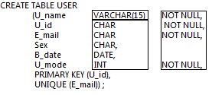

Also, we need to determine which attributes should be unique or primary key .After finishing this step, we also examined relations between entities via attributes. Finally, we generated the references by determining foreign keys to satify referential integrity of the database. For example in Spotify database almost every song is related with an album because each albums has many songs.To avoid redundancy we must create albums and songs in different tables and must connect them . That’s why we both added album id to the table of the songs and albums However to be able to do this ,their data types must be the same hence we formed it by taking this into consideration.Therefore, we satisfied the referential integrity of these tables .

Similarly, you can see the same data type for attribute “Album_id“ from these tables.

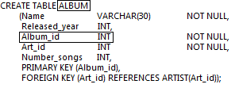

Also, you can observe referential integrity from Song table to Album table.

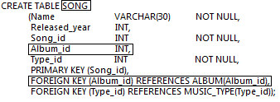

In normalization step, there exist no table with composite attribute,multivalued attribute or nested relations ,thus each table is in 1-Form.Also, all tuples in each table is uniquely determined by the primary keys and therefore they are in 2nd Form.All non-prime attributes depends only the primary keys.Finally all tables are in 3rd normal Form.All in all we created tables in our database via MicrosoftAccess.We used create statements such as:

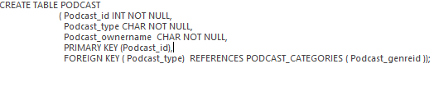

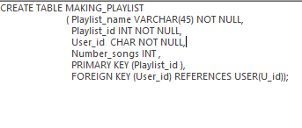

After creating all statements, we have such relations between tables:

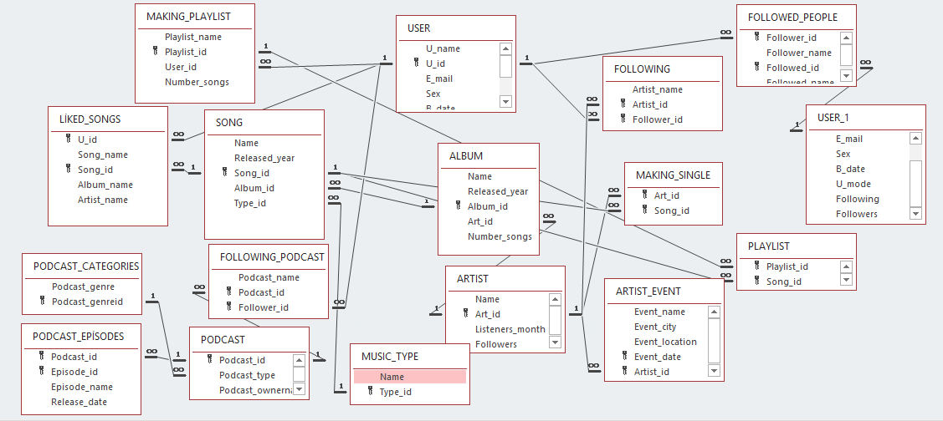

Uğur Bektaş Cantürk Gözde Gözütok

2215804 2216042